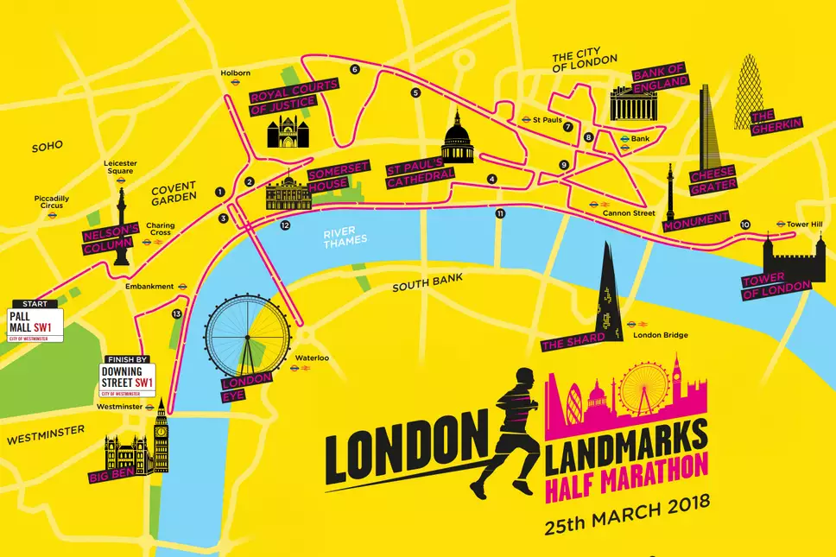
London Landmarks Half Marathon
24 March 2019
Back Up Guaranteed Entry Form
Allocation of guaranteed places will depend entirely on the information given on this form so please provide as much detail as you can. We ask all participants to pledge a minimum sponsorship of £350. The registration fee is £35 (includes a charity fundraising pack and a Back Up T-shirt).
Title | First name |  | Last name

Address
Postcode
Daytime number | Email
Date of Birth | Age on race day
Company | Occupation
Predicted finishing time (MAX 9 HOURS)
HOURS MINUTES SECONDS

How did you hear about the Back Up Team places?

Please detail any running events you have completed:

If you have taken part in other fundraising activities for Back Up or any other charity please provide details of the most recent in the box below, including dates and amounts raised:

Why would you like to cycle the Ride London 100 for Back Up?

We ask everyone that secures a place to raise a minimum of £350. Please detail the methods you will use to raise this amount.

Would your company consider doing matched funding for this event?

Are you happy for us to use any photos (taken by us/official photographers or submitted by you) of you for Back Up purposes? Y ES NO
Running vest/t-shirt:

Please circle: Male / Female

Please tick the relevant size:
□ Small □ Medium □ Large □ Extra Large

We would like to contact you with information about our services and how you can support us, including ways to volunteer, take part in research, how you can donate to us and how you can get involved in our activities, including fundraising, and events. We promise to always keep your details safe and we will never share your details with any third party.

Yes, please contact me by (please tick)
Email [ ] Phone [ ] Text [ ] Post [ ]

Your declaration
I understand that if I am accepted for a Back Up Team guaranteed place, I am required to pay a registration fee of £35 and commit to raising a minimum of £350 in sponsorship (excluding Gift Aid)
I agree to the Back Up Terms and Conditions with reference to London Landmarks Half Marathon
Signed | Date

Please take a copy for your records and return before 1st Feb 2019
alexandra@backuptrust.org.uk
Back Up Terms and Conditions
London Landmarks Half 2019
Charity place runners
- I understand that to participate I am required to pay a £35 registration fee.
- I pledge to raise the minimum sponsorship of £350. I understand that 100% of my sponsorship must be paid to Back Up within 1 month after the event date.
- Participants agree to raise the minimum sponsorship specified for the event.
- Participants agree that if they have not paid the minimum amount to Back Up within 4 weeks of completing the event they may be asked make up the shortfall themselves.
- Unless otherwise agreed in writing participants must not use their Back Up event for any other commercial gain, or use the challenge to fundraise for any registered charity other than Back Up.

General Terms and Conditions
- Participants agree to inform Back Up immediately if they are unable to take part in the event.
- Should you not take up your place all sponsor forms and monies should be forwarded to Back Up.
- All funds raised in connection with Back Up must be payable to Back Up in sterling. Please convert pledges to sterling.
- Participants give permission for free use of pictures, images, feedback and comments in any future advertising or promotion.
- You must carry out your fundraising in accordance with the guidelines set out in the Back Up’s Safe and Legal Guidelines.
- Back Up cannot take responsibility for any injury, losses or damage caused or sustained as a result of fundraising events held in aid of Back Up. Is it the responsibility of the event organiser, to comply with legal and safety regulations. The event organiser is Nova International.
- Back Up may, at its sole discretion, withdraw a participant if it believes that it is the best interests of the charity to do so.
- Participants must read and agree to the Terms and Conditions set by London Landmarks Half Marathon.
- We will be taking photographs and footage of the London Landmarks half event, for use in promoting the event and Back Up’s aims generally. They may be used in our own marketing or publicity materials, or distributed to external news outlets. Images will not be used for any other purpose.
- The copyright of any material which is generated as a result of this photographic session shall be assigned and shall be the property of Back Up.
- We will never use a child’s name alongside photographic images if they are under 12 years of age.

